Let’s get started with nice and easy examples of Batch script:

1. Open your favorite text editor. Save it as filename.bat (All files) right click on the file and

edit> type >

@echo off

echo Hello World!

pause

Run it. You have created your first batch file.

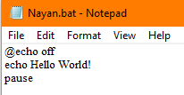

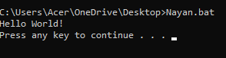

*Write the function of set up commands @Echo off and pause.*

**@Echo off:** Normally visible text is hidden. The '@' symbol hides the command 'echo off' from view.

**Pause:** It halts the line of commands after the ‘Pause’ command i.e., it pauses the batch file.

1. Create a batch program which takes two numeric inputs from the user and checks whether they are equal or not.

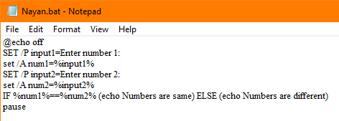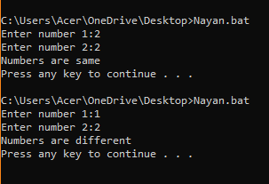

1. Create a batch program which takes a numeric input from the user and checks whether the input is odd or even.

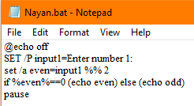

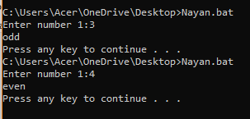

1. Create a batch program which prints natural numbers 1 to 10 using for loop.

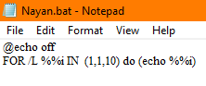

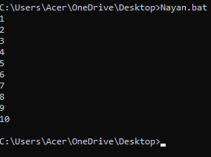

1. Create a simple calculator using a batch script. Which takes two number and third inputs can be “add” ,“sub”, “mul”, “div” and displays the result after calculation and displays error message for any other input in the third. eg: if first input is 2, second input is 3 and third input is add then it displays the result 5. Note: use function
2. Write a batch program to swap mouse keys.

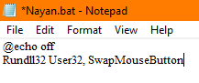

1. The following script is the malicious script responsible for system crash. Explain how it works and explain how you can protect your pc from system crash in Windows OS and Linux.

It is not permanently harmful for computers but annoying.

**Warning: do not run this script.**

**:S**

**Start %0**

**Goto S**

This script is known as ‘fork bomb’ and it is equivalent to DDOS attack on our operating system. This code firsts creates a label ‘S’, then ‘Start’ starts to run the script and ‘%0’ refers to the batch file itself. Hence, we are running the same file again. Then finally, ‘Goto S’ forms an infinite loop. Many systems will not complete 50 iterations before the system crashes.

Ways to protect the pc from ‘Fork Bomb’:

* Antivirus
* Limit maximum numbers of process (“MSconfig” for windows; “ulimit-u 30” for linux)